**SQL (Structured Query Language)**is a [domain-specific programming language](https://www.jetbrains.com/mps/concepts/domain-specific-languages/) designed to handle data in tables. It was developed in the 1970s. To this day, SQL-like interfaces are very popular in various data management systems, not only the ones based on tables!

Understanding such a popular language is likely to be very useful. If you are a software engineer, it's good to learn it because many systems store and process business data via services that support SQL. For example, the backend of an insurance company's information system may use SQL to extract and update data about their clients.

We will begin by looking at a practical example of how you can use SQL to calculate statistics. Then we will examine what the letters in the name SQL stand for.

**Calculating statistics**

SQL makes aggregating data and calculating statistics easier. Suppose you need to evaluate changes in the popularity of the name Jessie between 1920 and 2000 (inclusive) based on census data. Using SQL, you can complete this task with only 11 lines of code! You might not know the exact definition of each keyword of SQL yet, so try to read it as a sentence written in English. It selects records about individuals named 'Jessie' who were born BETWEEN 1920 and 2000. It groups them by year and gender, counts the number of records in each group via COUNT(*), and generates a table with columns named year, gender, and cnt. It also sorts the table by year and gender in descending order.

The "census" table:

|  |  |  |  |  |
| --- | --- | --- | --- | --- |
| **id** | **year** | **name** | **...** | **gender** |
| 1 | 2000 | Jessie | ... | M |
| 2 | 1880 | Kelly | ... | F |
| 3 | 1985 | Willie | ... | M |
| 4 | 2018 | Taylor | ... | M |
| ... | ... | ... | ... | ... |
| N | 1946 | Jessie | ... | F |

The query:

SELECT

year, gender, COUNT(*) as cnt

FROM

census

WHERE

year BETWEEN 1920 and 2000

AND name = 'Jessie'

GROUP BY

year, gender

ORDER BY

year, gender DESC

The query evaluation result:

|  |  |  |
| --- | --- | --- |
| **year** | **gender** | **cnt** |
| 1920 | M | 1590 |
| 1920 | F | 3329 |
| ... | ... | ... |
| 1960 | M | 935 |
| 1960 | F | 509 |
| ... | ... | ... |
| 2000 | M | 533 |
| 2000 | F | 710 |

SQL is the standard [data manipulation language](https://www.techopedia.com/definition/1179/data-manipulation-language-dml) used by data-driven companies around the world. There is a lot to gain from understanding it and plenty to learn. The best place to start is with the basics, so let's now look at what each letter in the name SQL means to find out what exactly we're dealing with!

**S is for Structured**

SQL is a language used to extract and update data **structured** as tables. This kind of data appears in various application areas, such as Excel spreadsheets containing accounting data, or census statistics in Google BigQuery. Another example is an online store that utilizes a special software system to store and access tables, known as a **Relational Database Management System (RDBMS)**. These can help to process the information on goods, orders, and customers.

SQL is intended for use with tables that have a particular structure:

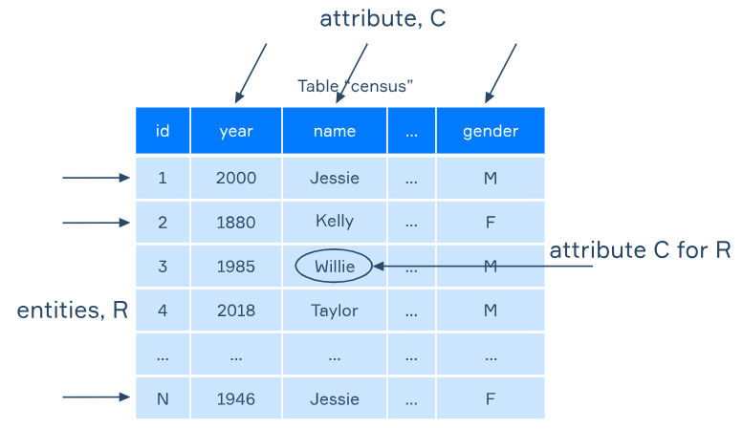

The tables contain**rows**and **columns**. Each row is an object or entity that has a set of properties or attributes. For instance, the third row contains data about Willie, a man born in 1985.

Data is often organized into a set of tables, known as a **database**. Then it's possible to access these tables using their individual names. For example, in an online store's database, a table called Customers would probably contain general information about the company's customers: their names and contact details. The Orders table would store information about the specific orders they place: customer names, goods, and payment details.

**Q is for Query**

SQL is a programming language with a large set of data processing features. It is **declarative**, meaning that a statement written in SQL can be a **query** that tells the system what should be done or evaluated but doesn't specify how.

In the next example, a query extracts all rows and columns from the table Census:

SELECT * FROM Census;

The * symbol is used to select all the columns from the table.

It's necessary to end each SQL statement with a semicolon, also known as a **statement terminator**. Else, there will be an error. A semicolon may be omitted only if you make one query at a time, but it is a good practice to always put it at the end of your query.

Keywords such as SELECT are not case sensitive in the SQL language. They can be in any letter case but are often written in all caps to make them more visible.

**L is for Language**

You can read the simple query in the above example as "select everything from the census." SQL was designed to be as similar as possible to a natural **language**. Its declarative nature helps to hide the operation's complexities, letting the user define what is required in a relatively straightforward way. The system then analyzes the query, chooses the control flow, and executes it.

SQL was originally adopted as a standard by the [American National Standards Institute (ANSI)](https://www.ansi.org/) in the 1980s. There are many dialects implemented by software vendors that support it. Dialects are based on the ANSI standard but have some technical differences. For example, they might process dates or strings differently. This means that SQL queries written in different dialects are not compatible. However, once you know the SQL basics, it's possible to adapt to dialects fairly easily, like with written American and British English.

MySQL syntax has been used in this topic and elsewhere on this website, so the examples may not be compatible with other SQL dialects.

**Conclusion**

SQL is a domain-specific, declarative language used when working with structured data.

You have learned that with data organized in tables, you can write SQL queries to select rows and columns according to various criteria, create groups of entities, calculate statistics, and much more!

Read more on this topic in [Database Design 101](https://hyperskill.org/blog/post/database-design-101) on Hyperskill Blog.

Are keywords like SELECT,UPDATE,INSERT case sensitive?

### ✅ ****Correct answer:****

**No** — **SQL keywords like SELECT, UPDATE, and INSERT are not case sensitive**.

### ✅ Explanation:

* In **standard SQL**, keywords are **case-insensitive**.
* You can write select, SELECT, SeLeCt, and they all mean the same thing.
* This behavior is consistent across most SQL dialects (e.g., MySQL, PostgreSQL, SQL Server, SQLite, Oracle).

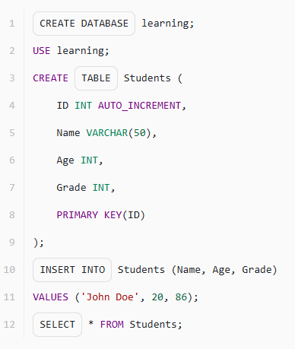

Select the name of the statement in SQL that tells the system what should be done with the table.

Query

Data organized into a set of tables that can be accessed by their individual names is called...

A database

Which query will return all the rows where theyear_of_birth is between 1980 and 2000 (inclusive)?

SELECT * FROM users WHERE year_of_birth BETWEEN 1980 AND 2000;

SQL is a declarative language. What does this mean?

Hint

Let's consider the example of ordering a pizza using declarative programming. In imperative programming, we would specify each step of the process, such as rolling the dough, adding sauce, cheese, toppings, etc. However, in declarative programming, we would describe the end result we want to achieve - a delicious pizza with our favorite toppings.

✅ **Correct answer:**  
**An SQL query tells the system what should be done with data but doesn't specify how**

### Explanation:

* SQL is **declarative**, meaning you **describe the desired result**, not the steps to achieve it.
* Example:

sql

CopyEdit

SELECT name FROM users WHERE age > 30;

→ You’re saying what you want — not how the database should filter, scan, or access the data.

### ❌ Incorrect options:

* **All software vendors declare...** → Not relevant to the **declarative** nature of SQL.
* **Specifies a control flow...** → Describes **imperative programming**, not SQL.

### 🔸 ****Real-Life Analogy: Ordering a Pizza****

| **Style** | **Description** |
| --- | --- |
| **Imperative** | You go into the kitchen and do everything step by step: make dough, add sauce, bake, etc. |
| **Declarative** | You tell the restaurant, “I want a large pepperoni pizza,” and they handle the rest. |

### 🔸 ****In Programming****

| **Style** | **Example** | **What it does** |
| --- | --- | --- |
| **Imperative** | for each row in users: if age > 30 then print name | Tells how to do it (step by step) |
| **Declarative** | SELECT name FROM users WHERE age > 30; | Tells what you want, not how to do it |

### 🔸 Summary

* **Imperative** = How to do it
* **Declarative** = What you want

SQL, HTML, and CSS are all examples of **declarative languages**.

What is a statement terminator?

It's a symbol at the end of the query. In case of SQL, it's a semicolon (;).

Select all the correct statements.

✅ **Correct answers:**

* **SQL was designed to be similar to a natural language**
* **There are many SQL dialects that are based on the ANSI standard but have some technical differences**
* **SQL was adopted as standard by the American National Standards Institute (ANSI)**

❌ **Incorrect statement:**

* **All software vendors support the ANSI SQL standard**  
  → **Wrong**: While many vendors **aim** to follow the ANSI SQL standard, most implement **dialects** with extensions or differences (e.g., MySQL, PostgreSQL, T-SQL).